GAME DESIGN DOCUMENT – PRANJAL PATANKAR

**The Title of my Project**

THE QUIDDITCH WORLD TOURNAMENT!

**The Goal of My Game**

The Goal of my Game: The players have to gain maximum amount of points in the given time (2 mins) without getting hit by an obstacle (the snake), and whoever gains the most number of points wins the game. This is a Multiplayer Game.

**A Brief Story about my Game**

There are four characters of Gryffindor in Harry Potter are in this Game – Harry Potter, Hermoine Granger, Ron Weasley and Alicia Spinnet. Like in the Harry Potter books, this is the Quiddich World Tournament. If the players touch the snitch, they gain 20+ points, and if they touch a snake, then they lose 20- points. Prevoiusely Gryffindor had lost a game against Sytherin, because of Draco Malfoy, a slytherin player, who hit Harry in the middle of the game and disabled his hand which recovered after a few weeks, so now Gryffindor wants to take revenge on Slytherin and win this game to prove them wrong.

**The Playing Characters of this Game**

* Playing characters are the ones who respond to the user based on the input from the user.
* Cars, monkeys, dinos, wizards, etc., are the playing characters in the game.

|  |  |  |
| --- | --- | --- |
| **SR. NO** | **Character Name** | **What can this character do?** |
| 1 | Harry Potter | Can fly using a broomstick and score points. |
| 2 | Ron Weasley  Ron Weasley - Wikipedia | Can fly using a broomstick and score points. |
| 3 | Hermoine Granger  Hermione Granger - Wikipedia | Can fly using a broomstick and score points. |
| 4 | Alicia Spinnet  Clarkson Quidditch Club Roster | Can fly using a broomstick and score points. |

**The Non-Playing Characters of this game?**

* Non-Playing characters are the ones that don't have an action or behavior when the user interacts with the game.
* Hurdles, stones, bananas, coins, etc., are non-playing characters in the game.

|  |  |  |
| --- | --- | --- |
| **Number** | **Character Name** | **What can this character do?** |
| 1 | Snake | It can make the character lose 20 points and acts as a hurdle. |
| 2 | Snitch | It can make the character gain 20 points and acts as a score booster. |

**My Imagination of This Game**

* Draw the game either on your computer or on paper.
* Add images of the game scenes to show each of the playing and non-playing characters at least once.

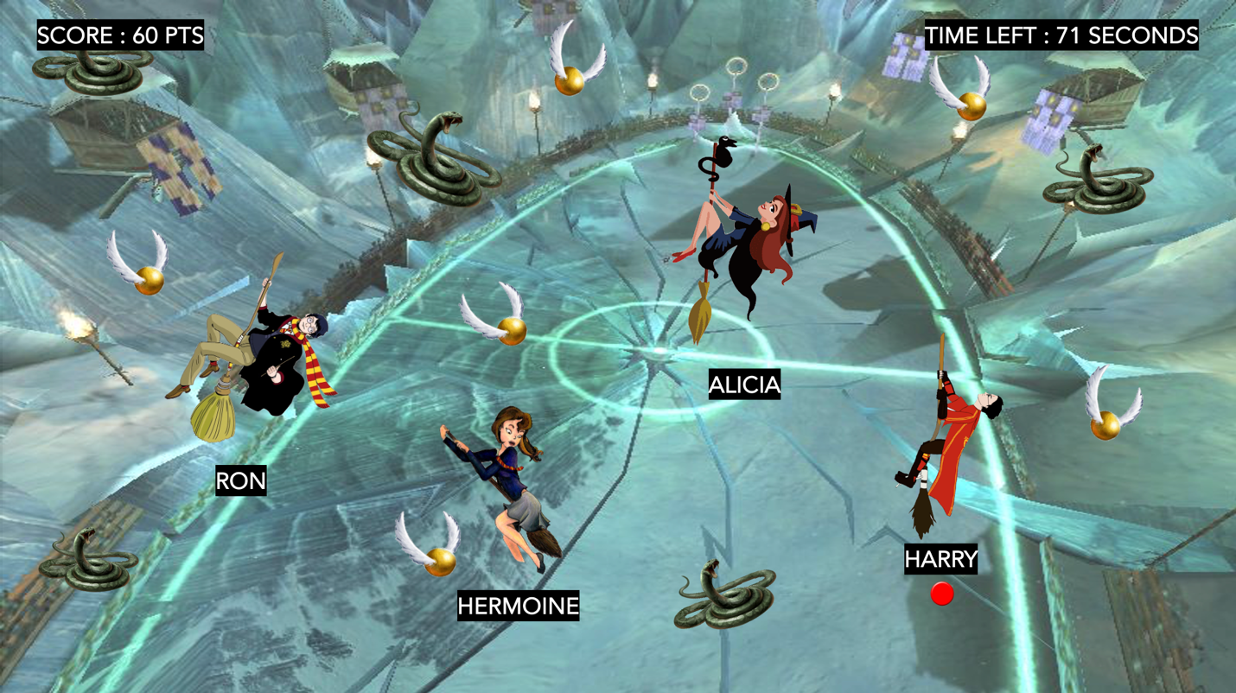

**How I plan to Make my Game Engaging**

To make this game engaging, I plan to add the harry potter music theme as the background music. And when a character touches the snitch and gains 20 points, an encouraging happy sound effect will be added, whereas when a character touches the snake and loses 20 points, a sad sound effect will be added. The characters will move by pressing the arrow keys. The background will move every few frames to make it look like the characters are moving forward. If a character wins the game by gaining the most number of points in 2 minutes, a “CONGRATULATIONS, YOU WIN!” Message with a sound effect will be added. The design and layout of my game can make this engaging and fun to play. Thank you!

|  |  |
| --- | --- |
| Device | Laptop / Desktop |
| Coding Platform | Visual Studio Code |

⎼⎼⎼⎼⎼⎼⎼⎼THE END⎼⎼⎼⎼⎼⎼⎼⎼